AMY PURDY – LIVING BEYOND LIMITS
TEDx Orange Coast
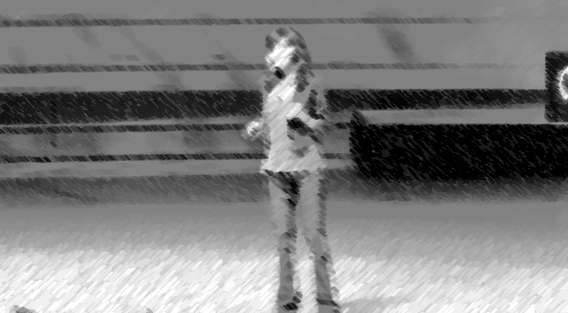
You just watched the story of an amazing young woman who had to learn a lesson rather quickly. While watching this, I’m interested in understanding what your thoughts were on the subject. Please complete the last two questions of Close and Critical Reading, as you continue
connecting outside stories to your own life.

3. What does the text mean? (Think deep here, what is the message that this woman is trying to convey?) Please write 6-8 sentences here.

_________________________________________________________________________________________________

_________________________________________________________________________________________________

_________________________________________________________________________________________________

_________________________________________________________________________________________________

_________________________________________________________________________________________________

_________________________________________________________________________________________________

_________________________________________________________________________________________________

4. What does it mean to me? I’m asking you to go big here. I’m sure that none have you have been in the same situation as Amy; however, I guarantee you can apply this story to you! Please write half a page on what you can learn from this story.

_________________________________________________________________________________________________

_________________________________________________________________________________________________

_________________________________________________________________________________________________

_________________________________________________________________________________________________

_________________________________________________________________________________________________

_________________________________________________________________________________________________

_________________________________________________________________________________________________

_________________________________________________________________________________________________

_________________________________________________________________________________________________

_________________________________________________________________________________________________

_________________________________________________________________________________________________

_________________________________________________________________________________________________

_________________________________________________________________________________________________

_________________________________________________________________________________________________

_________________________________________________________________________________________________

_________________________________________________________________________________________________

_________________________________________________________________________________________________

_________________________________________________________________________________________________

_________________________________________________________________________________________________

_________________________________________________________________________________________________

_________________________________________________________________________________________________

_________________________________________________________________________________________________

