CHIMBORAZO:
The Ulitmate Google Search

As we begin working on MLA citations, it’s a good idea to start getting used to proper research. Today, we are going to begin researching the Earth, which will then lead us to facts about other topics, and hopefully we can get back to Earth.

Rules: Start at Google.com. Type in “Earth facts” and click “Search”. I want you to read about the topic until you find something that you don’t know. In fact, make it something that your science teacher wouldn’t even know. Once you find an interesting fact, write it down along with the FULL website (for example: it’s not Wikipedia.com, it’s http://en.wikipedia.org/wiki/Earth), and the proper MLA citation. Once we are done, you are going to create an MLA works cited page by entering all of your information on www.bibme.org
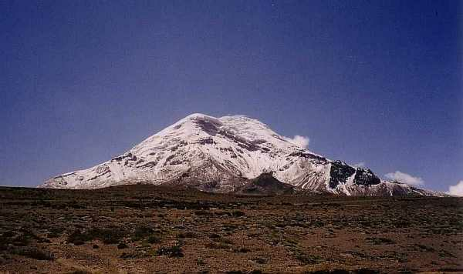

Topic: Earth

Website:___________________________________________________________________________________

Fact: (using MLA citations)

________________________________________________________________________________________________

_________________________________________________________________________________________________

_________________________________________________________________________________________________

Topic:

Website:___________________________________________________________________________________

Fact: (using MLA citations)

________________________________________________________________________________________________

_________________________________________________________________________________________________

_________________________________________________________________________________________________

Topic:

Website:___________________________________________________________________________________

Fact: (using MLA citations)

________________________________________________________________________________________________

_________________________________________________________________________________________________

_________________________________________________________________________________________________

Topic:

Website:___________________________________________________________________________________

Fact: (using MLA citations)

________________________________________________________________________________________________

_________________________________________________________________________________________________

_________________________________________________________________________________________________

Topic:

Website:___________________________________________________________________________________

Fact: (using MLA citations)

________________________________________________________________________________________________

_________________________________________________________________________________________________

_________________________________________________________________________________________________

Topic:

Website:___________________________________________________________________________________

Fact: (using MLA citations)

________________________________________________________________________________________________

_________________________________________________________________________________________________

_________________________________________________________________________________________________

Chimborazo: Work Cited Page

Please use the following sites to complete your workcited page:
http://owl.english.purdue.edu/owl/resource/747/02/
and
www.bibme.org

WORK CITED

