Lord of the Flies: The Beginning!
Key words of the unit: Survival, Evil
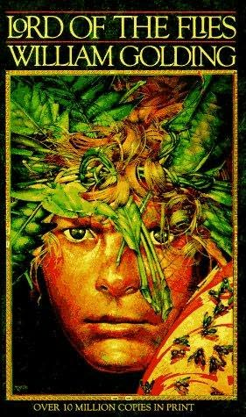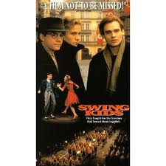

Questions to think about:

- As Peter becomes a “man” how does he change? What parts of himself does he lose? What parts of him remain? How do these personality traits help him survive?

- What (or who) was the most significant catalyst for Peter’s change? How did the chaos of the time help change Peter? How does the war in the world around him reflect the personal war he is waging? Is there any winning either war examined in this film?

- How does this film reveal the natural “beast” side of humanity? Where is Peter the least civilized? Where is he most civilized? Where does the idea of “humanity” and “civilization” start and end in this film?

- As the film ends, think about where Peter is going to go and how he is going to recover from his experiences. Based upon this film, is there any safe place in the world? What do you think the author/director of this movie would say about safety?

